1. Organisation Overview:
- Name: Pristine Renovations
- A Company that helps people renovate their homes
- They aim to help people renovate their homes at affordable prices.
- The aim to do these renovations as fast as possible but within a realistic time frame
- They turn outdated home interior and exteriors into the most pleasing and aesthetic homes
- Target audience – homeowners
2. Website Goals and Objectives:
- We will make their website more visually appealing
- We will help to improve the UX on mobile devices as the current implementation is poor
- We will help to increase the number of page views
- We will increase the amount of traffic through organic searches and social media
- We will decrease the bounce rate (make more users stay after viewing the first webpage
3. Current Website Analysis:
- The current website has very a poor user experience
- The photos used are not of a high quality
- The elements like buttons, text etc lack animations and transitions.
- Poor colour theory
- Paragraphs are too long, and don’t get to the point quickly enough.
4. Proposed Website Features and Functionality:
  - homepage describing who the company is, what you will do, how you will do it and the affordable pricing.
  - A good landing page (such as the below examples
  - 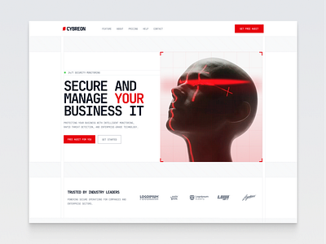
  - 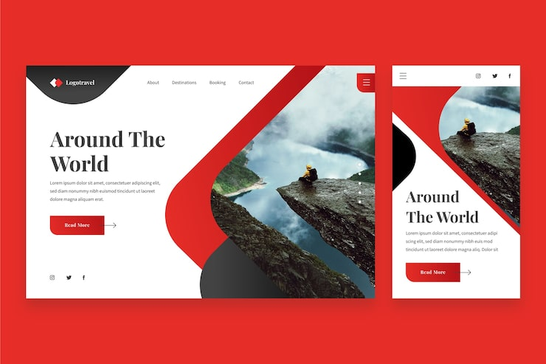
  - “About us” page that will detail the company’s contact information
  - A pricing page that will detail the different pricing ranges for different renovation needs but most importantly the affordable options must stand out as that is the business’ selling point
5. Design and User Experience:
  - Discuss the overall design aesthetic and branding, highlighting the following:
  - Colour Scheme: Red, black, grey and white will be the main theme
  - 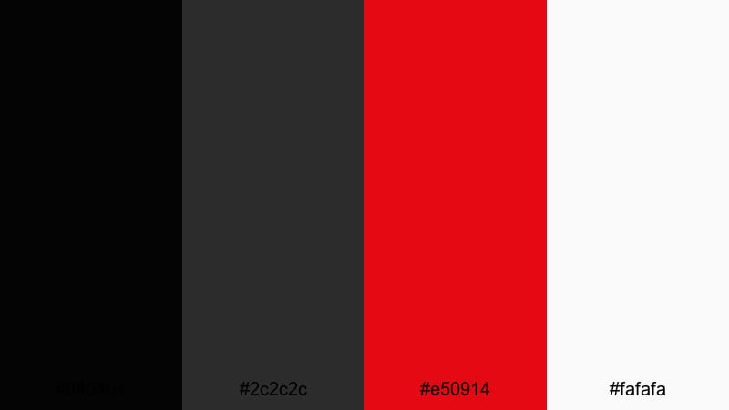
  - Typography: Arial font
  - Top Bar, Menu Links, Action button Main headline that is bold and large, High resolution imagery will be used, Lots of whitespace to reduce visual clutter.

  - Mobile-friendly UI. It will also work on ultrawide monitors too.
  - 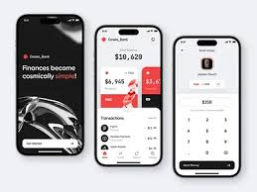
6. Technical Requirements:
- The website will use “.com” for its domain
- The website will use HTML, CSS and minimal JavaScript.
7. Timeline and Milestones:
  - The website will be completed within a time frame of 3 weeks, and constant communication and updates will be given regarding the state of the website allowing you to give feedback about things you would like to add, remove and slightly change.
8. Budget:
  - Website: R50000 (R10000 upfront deposit)
  - Hosting: R1000/pm
  - Domain: R500 /yr
  - Maintenance: R1500/per hour
9. References:
  - References listed here are unique to the chosen organisation and the researched documentation of the Website Project Proposal. The references listed in this document and the general references used to complete Part 1 will be compiled in the README.md document in the repository for the entire PoE.
  - Ronas IT. Bank App UI by Ronas IT. [Online] Available at: https://cdn.dribbble.com/userupload/8787332/file/original-e6b8606978a143b14106f001b790a2b0.png?resize=1024x768&vertical=center. [Accessed 06 August 2026].
  - Brown. 2026. Top 15 Black Red Color Palettes for Creative Projects With Hex Codes. [Online]. Available at: https://images.wondershare.com/filmora/article-images/crimson-noir-impact-black-red-color-palette.jpg. [Accessed 06 August 2026].
  - Landing example 1: https://cdn.dribbble.com/userupload/47392796/file/a10fdfc500bf47377fae69015243a5d6.png?resize=400x0. [Accessed 06 August 2026].
  - 2026.Cyberon – Website Template. [Online]. Available at: https://cdn.dribbble.com/userupload/47392796/file/a10fdfc500bf47377fae69015243a5d6.png?resize=400x0. [Accessed 06 August 2026].
  - 2026.Landing page travel with photo. [Online]. Available at: Landing example 2: https://img.magnific.com/free-vector/landing-page-travel-with-photo_23-2148378025.jpg?semt=ais_hybrid&w=740&q=80. [Accessed 06 August 2026].

